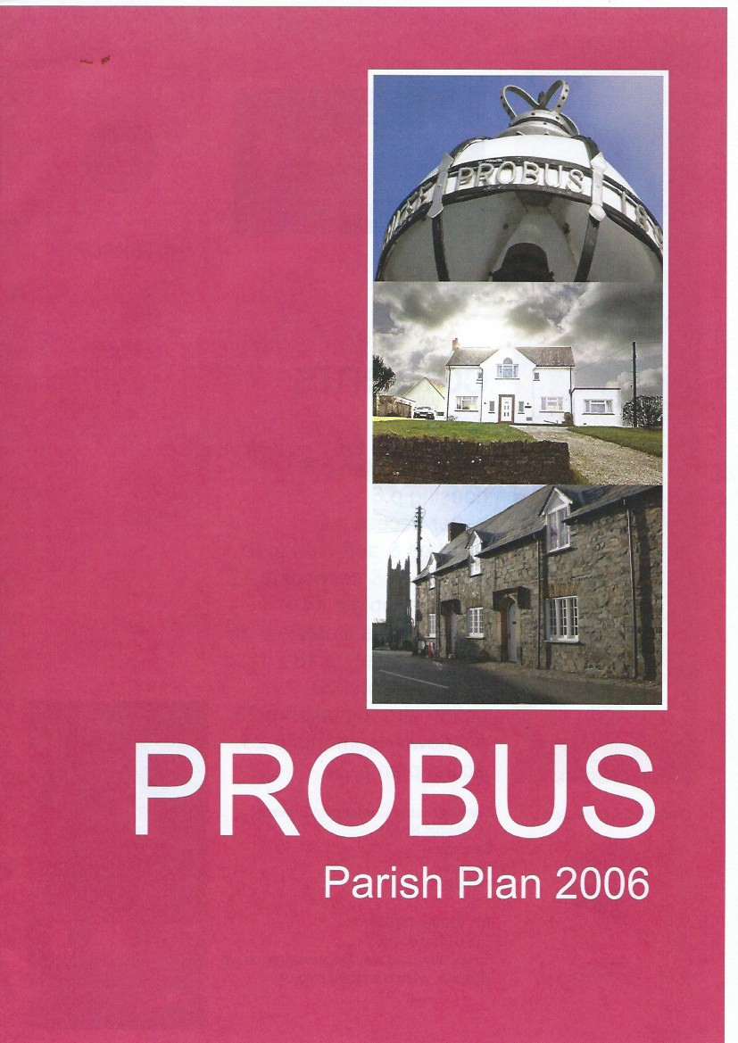

"'.

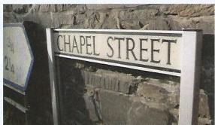
< >

V

Des igned & Produced by

crc c
VIONO-J kt ccmhh
Cl A'l'lfnlt<'ifii.S $U'l(A,t 1946

contents
introduction p.3 the parish plan p.4 housing p.6
better access p.8 facilities & activities p.10
education & services p.12 young people p.14
health active lifestyle p.16
crime & safety p.18 environment p.20
action already taken p.23 acknowledgements p.23 action plan p.24
Cornwall Rural Community Council 14 Chapel Street
Camborne Cornwall TR14 8ED

Tel: 01209 614950
Fax 01209 614951
Email: sharon.davey@cornwallrcc.co.uk Website: www.cornwallrcc.co.uk

2

INTERACT

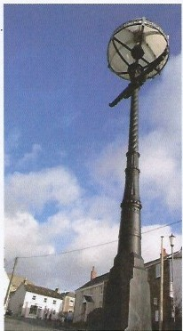

Introduction ...
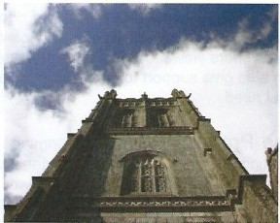
Probus Parish is situated in the centre of Mid-Cornwall and is known as the gateway to the Roseland, with Truro to the west, St.Austell to the east, Newquay to the north and the beautiful Roseland Peninsula to the south. It is a large vibrant village of approximatley 800 households and every year additional houses are built. A by-pass was built several years ago to relieve the village of the ever increasing road traffic between Tresillian, the adjacent village, and the end of the village boundary at Trewithan.

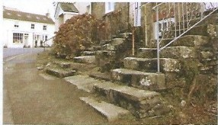
Historically, there has been a settlement at Probus since very early times, with the village boasting of the highest Church Tower in Cornwall. The Church dates back to 643 AD. Originally there were 4 farms surrounding the Square and Church, all have disappeared through housing developments but the parish itself is still surrounded by farms and farmland. Mostly, people travel to Truro and St.Austell for work and college but there is light industry such as garages, shops, a Doctors Surgery, which is expanding to carry out minor surgery, agriculture and an expanding Primary school which has a fine record of achievements.

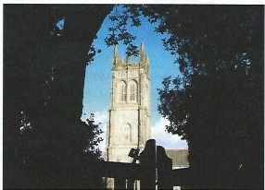
Probus has a very dedicatedfootball club and coaches who encourage young men and boys to keep fit and aspire to the top of the league. One of the targets of the plan is to improve the facilities for teams and the coaches, also to encourage young women and girls to take an interest in keeping fit.

Probus has many good points but these need to be harnessed so that the Parishioners can benefit from them. By producing the Parish Plan, having a public exhibition of the 3D map (made by children of the Primary School) and Officers from Carrick District Council to answer questions, the opinions and suggestions are now produced in this document. Lets see what we can make of it!

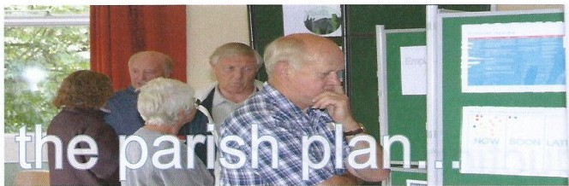

The Probus Parish Plan is a document that outlines how the community sees itself developing over the next few years. Its aim is to identify the hopes, needs and concerns of the community and draw parishionersviews together to form a strategy that will help shape the future of the the parish. The plan can also give support to local organisations seeking grants and funding as it demonstrates evidence of local need.

The Process began when Cornwall Rural Community Council (CRCC) attended a Parish Council meeting to explain about parish planning. The Parish Council were keen to take a Parish Plan forward and a Working Group of volunteers was set up to look at various areas where the living environment could be improved. A grant was successfully obtained from the Rural Key Fund, additional funds/help being obtained from Carrick District Council and West Cornwall Rural Transport Partnership, as well as Probus Parish Council's own contribution. This provided the funds for the Parish Council to undertake the consultation.

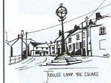Three questionnaires were prepared by the Parish Plan Steering Group
Probus Community

Consultation Questionnaire
- one forhouseholds, one for businessesand one for youngpeople in the parish. The household questionnaire covered a range of topics including housing & development, employment, community facilities, health, traffic & transport, leisure & recreation, employment and environment. This questionnaire was distributed in May 2005 with a return due date of the 31st May 2005. 207 questionnaires were returned, a response rate of 23%. Youth questionnaires were included with all household questionnaires. 19 questionnaires were returned. Business questionnaires, that focused on specific business issuesin the parish, were circulated by the steering group. 11 completed questionnaires were returned.

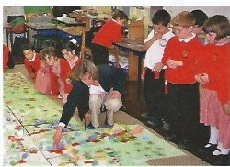
A Planning Event for local school children was held on Wednesday 25 May 2005 at Probus CP School. A 3D map of the village of Probus, produced by children from the school, took centre stage in one of the school rooms, giving everyone a bird's eye view of their neighbourhood. Displayed alongside the models were sets of pictorial colour coded suggesiton cards, and blank cards for the children's own ideas. All the children were asked to browse through these cards, select those covering issues that were important to them and place them on the map in the appropriate locations.

A Prioritisation Event was then held at Probus Village Hall on Saturday 17th September. The reasons for having this event were to feedback information to the community on issues that had arisen from the consultation, to reaffirm these priorities, to seek further comments and to look at future actions that could be taken, the partners that need to be involved and the possible time-frames in which projects could take place.

4

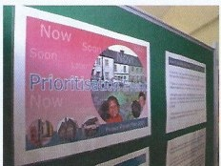
The consultation data has been used as a basis for writing this parish plan. The plan is split up into two main sections - The thematic section, which covers a number of topics (eg. housing, better access, young people etc.) and the action plan, which aims to provide an easy­ to-use guide to help tackle specific issuesidentified, focusing on actions that need to be taken, who else needs to be involved when tackling the issues(the partners) and the time scale for which each issue could be dealt with.

Key strategies, policies, principles and case studies are highlighted throughout the plan with the aim of providing ideas on how to tackle issues, as well as helping ensure that proposed actions are achievable and realistic. This informationmay be on a local, regional or national level depending on the issue.

One key initiative is the Cornwall Local Strategic Partnership/Community Strategy, which offers a joint approach on a county level when dealing with community needs, aiming to improve quality of life and helping ensure that services are delivered as economically and efficiently as possible.

The Community Strategy for Carrick takes this forward on a more local level, enabling local communities to be involved and coordinating the actions of local authorities and of the various public, voluntary, community and private sector organisations that will be working together to deliver the Strategy. The aim is to avoid duplication of effort and challenge existing methods of operation. The Strategy is responsible for seeking involvement and commitment from public, private and voluntary partnerships and organisations in order to deliver agreed actions and helping attract investment into the Carrick area.

Carrick District Council are alsocurrentlyin the process of formulating a Statement of Community Involvement (SCI) which outlines how and when the community can

oom it,
pl11nnln 9

=
get involvedin the planning system. The document sets out how Carrick District Council will involve communities in preparing and shaping the different parts of the new Local Development Framework and how residents can get involved in significant planning applications, both before and during submission. The Statement of Community Involvement forms part of the Local Development Framework. Carrick District Council state that once the statement is finalised,·a11 subsequent planning documents and consideration of all planning applications will have to adhere to it.

Sustainabiilty needs to underpin any actions suggested within the plan. The concept of sustainability encompasses environmental, social and economic issues, and is often defined as 'Meeting the needs of the present without compromising the ability of future generations to meet their own needs'. Although it is a global issue the principles of sustainability are applicable on a local community level and need to be borne in mind when looking at a whole range of issues including the longevity of community projects, transportation patterns and impacts of future development.

Links between issues need also to be noted to ensure that actions within the plan are taken forward in a cohesive and holistic way. For example, if looking at providing youth activities, other issues such as public transport and accessibility would need to be considered. For this reason, each of the theme sections signposts to any related issues within the action plan.

61% of residents attending the prioritisation event felt that affordable housing was a priority. Many residents also stressed the importance of houses being available for local families, the young and the elderly. Concerns were raised by residents as to how affordable housing could be provided and, once built, how such housing would remain affordable. Carrick District Council can use a number of methods to enable the delivery of affordable housing schemes, including: supporting bidsby Housing Associations for Government subsidy funding relating to specific affordable schemes for social rented, shared equity and low cost dwellings, providing some financial support including the allocation of specific contributions from related developments, incorporating strong and reasonable policies and guidance within new Local Development Framework documents as well as those within existing Local Plans. The Council is also seeking to progress plans to allocate land within the framework documents with a requirement to deliver affordable housing for the local need of rural village communities.

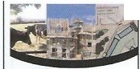Probus itselfhas beenidentified intheRuralHousingAllocations document as one of the larger villages in the district in terms of population size, service levels and commitynfacilitieswhere there could be the opportunity to provide affordable housing in a more sustainable manner to meet an established level of local housing need. One of the popular potential option sites for housing is the land currently occupied by the St Merryn Meat Factory on St Austell Road, which has now closed. The site obtained 94 responses in favour of housing development in the household questionnaire. Consultation is currently taking place in regard to the possibility of allocating this land for housing. If this land is allocated the majority of residents would like to see these homes being affordable for local people. There were also requests for the development of extra community facilities, such as a new community centre, to be built along such development.
ti
•-m••"'
::::•
--- -
Issues were raised by residents as to the visual and environmental impact such
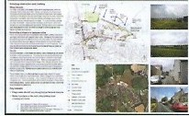housing could have on the parish Carrick District Council argue that the benefit of the St.Merryn Meat site is that as there are existing buildings on the main part of the site, any new development should not have a significant impact on the landscape. It is also stated in the concept plan that appropriate development could even enhance the character of the village.
,..._,....

Another site being considered through the Rural HousingAllocation process is the land adjoining the Doctors Surgery on Tregony Road. The scheme has the potential to be integrated with an extension and upgrading of the adjoining surgery. It is noted that issues of access in relation to the surgery and also pedestrian access through to the centre of the village will need careful consideration. Carrick states that 'whilst a number of other

'This village is seriously lacking in affordable housing for first time buyers, young families/single parent families.' Residen t's comment

6

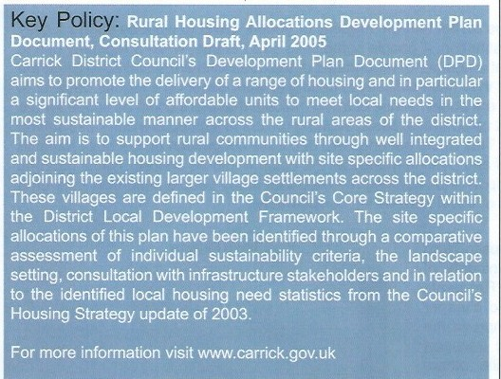Statistics....
'My fear is that this village will continue to grow into a commuter, dormitory town and lose all the character of a Cornish
village'
Resident's Comment

61%of residentsattending the prioritisation event felt that affordable housing should be of precedence if there was future housing in the parish.

The household questionnaire revealed:

244 were in favour of affordable homes for local people.

179 thought the parish needed homes for young people.

133 thought the parish needed more small family homes.

128 highlighted the need for housing for older people and those with disabilities.

sites have been suggested for the village, key concerns have been remoteness and proximity to the main facilities, encroachment into the landscape areas that are critical to the village setting and sites being too extensive and out of scale with the needs of the community'.

Action Plan...

Affordable Housing Development Youth Facilities

p.24 p.39 p.34

Comments were also made by a number of residents about the need for development to be limited to preserve greenfield sites and ensure that Probus remains a village. Infrastructure concerns have also been highlighted by residents and these will need careful consideration if proposals for extra housing go ahead.

Key Points:
- There is a need to supply an adequate amount of affordable homes for a range of people within the community including local residents in housing need, first time buyers, young people and elderly people.
- Infill/brownfield sites should be utilised for housing development wherever possible.
- The need for low cost housing of all tenures should be monitored via the district and local needs housing surveys.
- Parish Council will need to continue to work with Carrick District Council to ensure the number of
new properties are limited and in keeping with the area.

- Infrastructure will need to be considered if housing development is to proceed e.g. sewage system, local facilities, parking and access.
7

Grampound

Work travel patterns in Probus reveal that the majority of people travel to work by car on a daily basis, with Truro being the main destination. 4 people sometimes use the bus, while 3 regularly use it. Truro is the only work destination that a number of repondents of the questionnaire travelled to using the bus service. 21 residents stated that they have difficulty in getting to work either on a regular basis or in the summer months when the roads are busier. Times of travel indicate that there could be scope for car sharing. Such a scheme could be set up on a local basis, allowing drivers to sign up to a database stating when they were willing to share lifts. This would not only help decrease congestion on the busy roads to Truro but also save residence petrol and parking money as the costs would be shared. Travel patterns for other activities such as leisure, sport and shopping revealed that many people used their cars on a weekly basis to access them. Times of travel here varied considerably.

Publictransport links from Probus to Truro , are good, although only a small minority of residents use the service regularly. Residents stated a more frequent, reliable and cheaper service as key ways in which to improve the , service. 193 people thought public transport was easy to find out about, while others commented that advertising bus times in
places such as the parish magazine would help

Work Travel Patterns

□

increase a wa re ness of services. Integrated D D
ticketing between bus operators may also be Truro S t.Aus te ll T ruro& Roche an optio n that should be pursued. The Rural st.Auste11 Transport Partnership tries to encourage each Dc<llnation
D D
Red(Ulh Bodmin

parish council to appoint a Local Transport Fig 1. Chart showing travel destination and number of
Representative (LTP) who can act as a residents travelling to work by private car.
local champion, feed back on issues like bus reliability and other issues,_and play a role in improving information. Around 75% of parishes in West Cornwall have now appointed a representative. At present the_re is not an LTP for Probus, and appointing one should be a priority.

Community transport is curren tly used by 12 respondents, while 80 respondents said they would use the service if it was extended. Extending the service however, relies on gaining enough volunteers to be able to put on the services required. There are presently plans to try and get a community bus going in the area. Such a bus might be able to help, amongst other things, with the issue of organised trips for young people and improving their access to facilities outside the village.

'More needs to be done to encourage people to use public transport. Why not have integrated ticketing between bus operators.'
Resident's Comment

8

Statistics....

'Bus timetables to Truro and St.Austell could
be published and updated in Probus news.' 73%of respondents to
Resident's Comment the questionnaire staled that
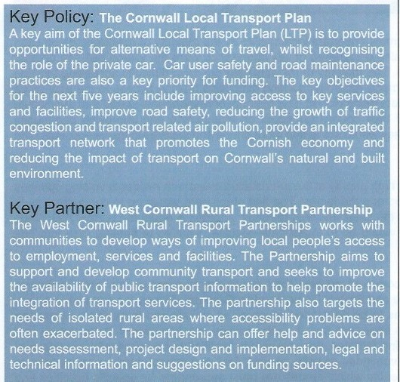
heavy goods vehicles should be banned from Probus village.

Resident's views on improving public transport:

134 residents would like to see a more frequent service.

113 residents stated cheaper fares would encourage them to use the bus.

109 residents required a more reliable service.

60 residents wanted better information.

Action Plan...

Public Transport p.24 Traffic & Safety p.25 Accessibility p.25

Road Safley was another key issue to be highlighted in the questionnaire and at the prioritisation event. Key areas of concern were Fore Street, Tregony Road, St.Austell Road and near Probus CP School. Parking problems were also highlighted through the consultation, with cars being parked in inappropriate places hindering accessibility within the village as well as being a safety hazard. It is important to remember, however, that providing additional parking and providing for the private car can undermine the efforts to encourage people to use alternative means of transport. Ultimately, this can lead to more cars on the road and greater congestion problems in the future. The majority of residents also thought that heavy goods vehicles should be banned from driving through the village. These issues are discussedfurther in the 'Crime & Safety' section.

Key Points:
- There could be scope to improve access in Probus through the Parish Council working with Cornwall County Council and West Cornwall Rural Transport Partnership Officer (WCRTP) to improve public and community transport systems, as well as the possibility of instigating a car sharing scheme.
- Road safety issues, including traffic speeds and heavy goods vehicles in residential areas, need further investigation, with the view of setting up a working group to monitor levels of road use and
propose possible actions to improve access and safety.

- Problems of congestion on main roads and the safety implications of illegal and inconvenient

The Post Office was rated the most important local facility by the majority of residents, being cited by 94 respondents. Other facilities also considered of key importance were the village hall, the doctors surgery, the shops and public toilets The majority of residents did not have difficulty accessing existing facilities, although comments were made regarding parking difficulties making access to the post office difficult and problems with public toilets being closed The majority of respondentsstated that they would be prepared to see a proportion of their council tax spent on maintaining and improving community facilities. Young people also stated they would like to see more shops and facilities in the village, including an internet cafe.

Probus Village Hall was given high priority at the prioristation event with residents voicing opinions that there was an urgent need to upgrade the facility. The first steps here would be to conduct an audit of community facilities and consider the costs involved to repair, improve & equip the current hall. Once this has been done the next stage would be to investigate possible sources of funding (see info box opposite).

Residents were invited to comment on how they would like to see two key sites in Probus redeveloped, the St.Merryn Meat site and Probus Demonstration Gardens. Among the suggestions were requests for new community facilities to be developed which could include sports facilities, computing suites and educational rooms. It is important that if such facilities are considered in the future that they do not rival or undermine existing facilities. For community facilities to be successful it is vital that
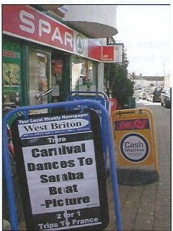committees of halls, playing field and school, work in partnership to identify which venues are most appropriate for specific activities and work on ways in which the facilities can compliment each other.
•

Hobbies and pastimes that are favoured by residents include gardening club, computing, arts/crafts, cinema, concerts, ballroom dancing and languages. Further investigation would need to take place to deterr:nine wh ich of the interests could be catered for in th parish and which venue would provide a suitable location. It is important also to promote existing activities and groups to parishioners. This could be done through advertising in the parish magazine and/or on the parish website. Many residents, includingyoung people, also favoured additional community activities in Probus such as the introduction of an annual carnival and parade in the village. A working group could be set up to research the feasibility of such an activity, looking into funding, insurance costs, health & safety and entertainment laws.

A multi-use community hall could be built on the St.MerrynMeat site'.
Resident's Comment
10

'With the loss of the venue for adult education .classes at Probus Gardens, an alternative venue should be provided'
Resident's Comment

Statistics....

72% of residents attending the prioritisation event stated the village hall was an issue that needed to be tackled either 'Now' or 'Soon'.

Facilities most importantto residents:

94 voted for the Post Office 92 voted for the village hall 87 voted for the surgery 70 voted for the shops
60 voted for the public toilets

Action Plan...

Community Organisations p.26 Public Open Spaces p.26
Indoor Sports p.29
Village Halls p.27
Youth Activities p.32
Park Facilities p.33
Skate Facilities p.33
Team Sports p.34
Youth Facilities p.34 Probus Primary School p.30 Learning Opportunities p.31 Public Transport p.24
Village Halls p.27

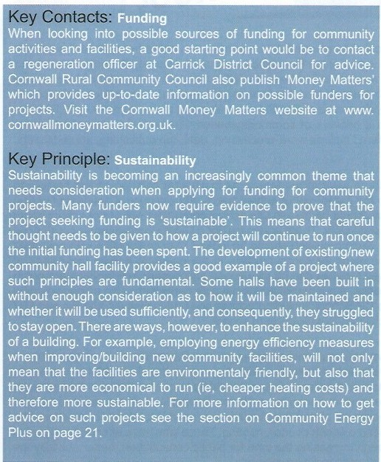
'The Demonstration Gardens could be re-developed as a new village hall sports complex. Not everyone wishes, or has the transport, to travel to St. Austell and Truro.' Resident's Comment
Key Points:
The continuation of use/development of village hall facilitiesneeds to be ensured through conducting
an audit of facilities and consider the costs involved to repair, improve & equip the hall.
•

•
- A working group could be set up to look into the feasibility of community activities such as an Annual Carnival/Parade in the parish.
Existing facilities in neighbouring parishes should also be investigated.
avoiding duplication of work and competition.
CRCC, to develop community facilities as requested by residents through on going consultation,
Village Hall, Playing Field Committee and School need to work in partnership, seeking advice from

•
11

Probus CP School educates local children aged 4-11 and has been noted by residents as being a great asset to the community. Probus is part of the Roseland Learning Community Schools Network. An audit of schools current provision and needs has just been carried out and a meeting of the Heads is due to take place on 27th January 2006. It is anticipated that Probus will be joining with Ladock, Grampound andGrampound Road Schools to provide services. The School is also part of the Community ICTAcross Cornwall Project. This scheme offers a network of community-basedOutreach Centres where adults can learn computer skills. Courses offered include word-processing, desk-top publishing, spreadsheets, databases and website design.

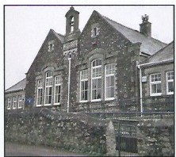While there were mixed feeling as to whether children should be able to access the library out of school hours, the majority of residentsfelt that children should be able to use school computers outside of school hours to complete work. There is alsocall for a floodlit football/tennis court at the school. Such provision should be looked at in conjunction with any other possible plans for sports facilities in the parish to ensure that usage of proposed facilities can be maximised and ensure that facilities are not in competition. A number of additional comments were also made regarding Probus CP School, including access and parking issues and the need for more children to walk/cycle to school.
1

The questionnaire revealed that 356 residents were aware the Parich Council existed, while 8 did not. Most residents were either very or fairly satisfied with the service it provide. Many comments, however, were made by residentsas to how the Parish Council could be improved.Many of these related to the need to get more people interested in becoming a Parish Councillor and the need to consult and involve younger people. 18 respondentsstated they would be prepared to stand for election. The majority of residents have never attended a parish council meeting. Those who have attended suggested that meetings could be improved through increasing the time for public consultation, better publicity the meetings and displayingthe meeting agenda more prominently.

Child Care facilities are currently used by 29 residents. Most residents who use childcare services outside of Probus do so because there are no places available in Probus. There is currently one pre­ school in Probus providing 42 sessional places in the village hall. There is also another pre-school in Ladock Road, but that is a few minutes drive away and not within 'pram pushing distance'. There are 2 childminders in Probus. Full day care provision in the village is therefore through childminders. The majority of full day care can be accessed in the towns outside Probus. The most popular suggestion for improving childcare services in the parish was to expand the services.

'Probus School is continuely improving, striving to be at the heart of the community. It provides great opportunities for our children'
Resident's Comment

12

Statistics....
'The Parish Magazine is excellent. I use it as my first port of call to locate a trades person and have used several local companies.'
Resident's Comment

Where residents work:

15 work from home
21 work in Probus village 17 work under 5 miles away 83 work 6-1O m iles away 49 work 11-30 miles away
12 work over 30 miles away

Action Plan...

Probus Primary School p.30 Learning Opportunities p.31 Local Businesses p.36
Public Transport p.24
Village Halls p.27

Employment questions within the household questionnaire revealed that 15 residents work from home while a further 21 residents work in the village. The most common distance travelled to work was 6-10 miles, being stated by 83 respondents. Of the repondents who do not currently work in the parish, 60 said they would like to, with a mix response requesting either fulltime or part time work. The business questionnaire revealed that there were a small number of businesses within Probus that required training. These included IT, fire safety and tourist support. Favoured locations were either at their own premises or at a training centre/college. 4 businesses responding to the questionnaire stated they were looking to expand, while only one business was possibly looking to move to new premises within the parish.

The Parish Magazine is read by 370 respondents and the vast majority of readers rate the publication as excellent. Comments for improving the magazine included encouraging more residents and local groups to contribute, publishing more information (eg. bus timetables), sending the magazine to the outlying rural areas and including more articles for young people. The parish also has a website that provides a range of information about the parish includirig news, facts .and figures, information on clubs, groups and services, photos and contact details. The questionnaire revealed that 258 repondents were aware of the site, and of these 121 had visted it. Suggestions for improving the website included the need for it to be more regularly updated and the need for more information on clubs and sports. Such improvementsof course rely on residents contributing to the website. The Probuswebsite can be visited at www.probusvillage.com

Key Points:
- Investigate the possibilities of providing local learning/training facilities. Church hall, school or village hall facilities should be utilised for local classes.
- Futher consult local businesses in regard to training opportunities, promoting existing business,
the possibility of a local chamber of commerce type organisation specifically for businesses in
Probus, expanding business or moving to new premises.
- .
work in
Explore training/learning needs and identify access to these if they cannot be provided locally
partnership, looking at ways to best provide training opportunities for local residents.
should
Department
County Council Adult Education
Parish Council and Cornwall
•

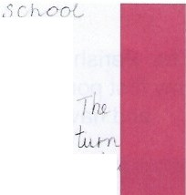
(
0
...0...

=- ...fu-x
@lUJuui ₀ [µ;®@[P)ll®0 = i=.x l ' '-
Youth consultation revealed that the key things young people liked about living in Probus revolved around the friends they have in the village and the activities they undertake, while things they dislike centred on the anti-social behaviour that took place at night and the need for more things for young people to do within the parish. Many older residents also recognised this need, with suggestions being made from both young people and adults that a meeting place and more clubs to attend were needed. At present there is an out of school club (Probus Kids Club) at the GP school, together with a holiday scheme. Popular suggestions for additional activities included pool, organised trips out and discos. Leisure and sport issues also featured highly in the youth consultation, with 205 suggestions being made at the planning event and many comments being made in the youth and household questionnaire. The majority of young people aged 11-16 felt the park was currently inadequate. Suggestions for improving it included providing more for older children to do and providing toilet facilities. The park was also the most popular location for lighting to be installed to enable young people to congregate after dark.
Leisure & Sport Suggesluions

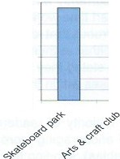18
.",' 16 - -

14
0
> 12
0 10
:;; 8
,D
6
E
z:, 4
2
0
- - - -
I ·

F a cili t ies

Fi g 3. Chart showing the most popular leisure and sport activities to be highlighted by young
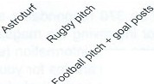
people aged 4-11.

The most popular suggestions made by the the 4-11 age group related to the provision of a skateboard/roller blade facility, followed by the need for an arts and craft club, cricket facilities and an astro-turf area. The King George field and the school were the two most popular locations for such facilities. Skate facilities were also popular with the 11-16 age group, with the playing field being cited as the most popular location. The first steps in looking into issues such as skate provision would be to contact Carrick District Council's Recreation Officer. Further consultation will also be required to further determine the kind of facilities required by young people in the parish. There are a number of different options that need to be looked into. If skate facilities are favoured, it needs to be established whether

'Youngpeople in the village need their 'own space'. Measures to stop them congregating in the village centre does not solve the problem.'
Resident's Comment
14

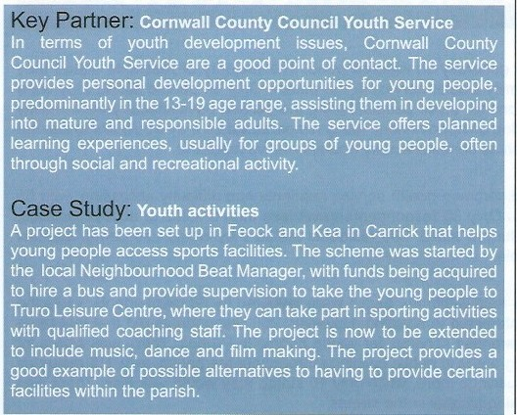Statistics....
'It is a pleasure to live in Probus, but we would like more organised
events and activities.'
Young Person's Comment

69o/o of respondents aged 11-16 feel that the park is
inadequate.

11 - 16 year olds interest in activities:

16 favoured pool
15 favoured organised trips out
12 favoured discos
12 favoured darts
9 favoured a cinema club
7 favoured bowling

Action Plan...  Youth Activities | p.32
Youth Facilities | p.34
Park Facilities | p.33
Skate Facilities | p.33
Team Sports | p.34
Youth Fac ilities | p.32
Public Transport | p.24
permanent or mobile facilities are more appropriate for the parish. If mobile facilities are deemed more appropriate then discussions should be held with Carrick District Council in regard to the possibility of such facilities being supplied by the Council. Other parishes in the area with similar needs should also be contacted with the possibilities of working in partnership, making the likelihood of such provision more viable. If permanent facilities are favoured there are many issues such as location, design considerations, management issues and funding opportunities that need to be looked into. Although it may not be sustainable for a small community, such as Probus, to provide facilities for more advanced skaters, facilities on a scale to suit younger/entry level young people, who are likely to be more restricted in the distancethey are allowed to travel from home, could be a more realistic option. It is also important to bear in mind that helping young people access facilities outside the parish may sometimes be a more realistic solution than trying to provide them all within the parish (see case study above).

Key Points:
- Assess feasibility of a range of youth activities/sports in the parish (i.e. tennis, archery, basketball, swimming pool, rugby club, arts & crafts club and disco's) researching costs & funding, venue, likely numbers of attendance and format (different age group sessions etc.).
- A community based group should be set up consiting of potential users, volunteers and Parish Council.
•
Lobby District Council in respect of need for skate facilities, and the development of a district wide
skateboard strategy (as in Penwith & Caradon districts).
Advice is available from CCC Youth Service on how to set up and run a youth club, in terms of
•
legislation/responsibilities etc.
- Young people should be consulted and involved in all stages of a youth project.
- It is important to bear in mind the changing needs and interests of young people as they get older.

Health facilities in Probus are generally considered good. The majority of residents stated they were very satisfied with the GP/Familly Docter service in the parish. Only 10 people stated they were not satisfied with the service. Reasons for these people finding the service unsatisfactory were mainly concerned with having difficulty making an appointment. Many residents stated they would like to see the surgery offer additional services such as complementary and alternative medicine.

Dentist facilities were the most common health service residents had difficulty accessing, with 55 respondents stating it as a problem. Only 36 respondents travel less than 5 miles to access facilities, while the vast majority have to go further afield. 303 residents stated they would use dental facilities based in Probus if they were available.

Health education seminars held within the parish were favoured by 98 respondents, while the majority stated they would not be interested in atteding. However, 255 respondents did feel that there should be health education and awareness services for young people in Probus. There was also a lot of support for separate non-smoking areas in public buildings throughout the parish, with 115 residents stating that they would visit these buildings more, while only 10 stated they would visit less. There was also great support for a ban on drinking alcohol in the streets.

Footpaths are currently used by 232 respondents. However, just over half of respondents stated they did not know where most of the local footpaths were. Feelings were mixed as to the quality of the footpaths in terms of signposting, maintenance, routes and ease of access, some residents rating them as good while others stating they were unsatisfactory. 296 respondents were in favour of information being produced describing local walks, giving details on length of walk, flora and fauna, and sites of historical interest. The majority of residents however, did not feel that there was need to create new footpaths in the parish. 62 respondents stated they would like to become actively involved in a footpath society to help clear and maintain paths in the parish.

Sports facilities, such as a multi-gym and tennis courts, were popular requests of activities residents would like IQ undertake in the parish. Comments were made by residents that the provision of these facilities were even more essential if there was going to be future development. The need for sports facilities was also a key issue to come out of the youth consultation with the provision of tennis courts again being a popular request (for more information see 'Young People' section).

'The parish needs more provision for recreation facilities, both indoor and outdoor, before anymore housing is built.'
Resident's Comment

16

'Sports facilities are inadequate. We need a larger area.'
Resident's Comment
Case Study: •· • •

•

Statistics....

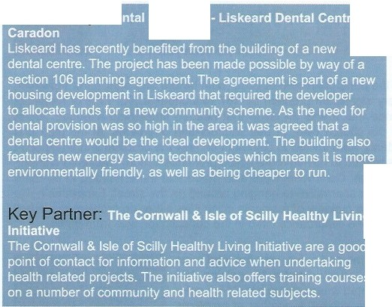80% of residents would like to see separate non-smoking areas in public buildings in the parish.

Most popular sports facilities

67 favoured outdoor tennis 58 favoured a multi-gym 43 favoured indoor tennis 26 favoured table tennis 26 favoured badminton
23 favoured aerobics

Action Plan...

Access issuesalso need to be considered. Forexample,atpresent there are problems with elderly people getting to the Village Hall for exercise classes.The class is designed specifically for them, but as Probus is a linear village, elderly people living at each end are put off walking to the village hall. Access issues to facilities for young people also need consideration (See 'Young People' section).
Dental Facilities Open Spaces Village Halls Outdoor Sports Indoor Sports Park Facilities Skate Facilities Team Sports
p37 p26 p27 p.28
p29 p.33 p.33 p.34

Key Points:
•
A working group should be set-up to refer to report data and identify level of sports requirements
within the parish such as, a gym, tennis, badminton, bowling, cricket and aerobics.

- It is of key importance to promote existing facilities/activities within the parish (e.g. Bowling Club).
- Further investigation should take place into what existing facilities are available in or near the parish (e.g. Truro, St. Austell). Consideration needs to be given to whether it is more feasible to
access these existing facilities through looking at transport solutions.

- Discussions need to take place with young people in the parish to further refine the sports clubs and teams they would like in the community (e.g rugby team, basketball team, cricket team, tennis club, running club etc.)
- Discussions need to take place with both the Parish Council and District Council to determine
encourage volunteers to help train teams and run clubs.
Parents, residents and young people need to be involved in projects and there is a need to
possible sites, facilities and funding opportunities
.
•
17

The majority of residents in the parish feel safe outside, both before and after dark. H9wever, vandalism was rated a significant/very significant problem by 167 respondents and 77% of residents attending the prioritisation event stated that it was an issue that needed immediate attention. Areas of specific concern included around the church yard, at bus shelters and bus stops, at the park and playing field and in the square. Residents were invited to comment on how the problem should be dealt with. The majority of these comments related to having more police presence/action, fines/enforcement, punishment, education and parental action. Comments were also made that there needed to be more facilities for young people to give them an alternative to hanging around on the street. Excessive noise was considered less of a problem, with the majority of residents citing it as either no problem or a small problem. The most common source of noise disturbance cited in the consultation was from traffic.

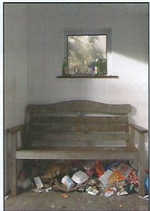
Youth consultation revealed that crime and safety was the third most important issue for young people in the parish aged 4-11, gaining 164 responses. 23 of these responses highlighted where young people felt safe, the place to get the most votes being the school. A number of problems were highlighed in the parish including drug dealing, graffiti, the need for security lights and the need for a police footpatrol.

Traffic and safety was given third priority at the Prioritisation Event, with 60% of people attending stating it as an issue that needed to be dealt with immediately, with a further 8% saying it should be dealt with soon. Speeding was rated as a very serious problem by 100 respondentsand a moderate problem by 146 respondents. Key areas of concern were Fore Street, Tregony Road, St.Austell Road and near Probus CP School. The most popular suggested solution to this problem was the installation of a flashing speed limit sign, which was requested by 171 respondents. Other
favoured methods of reducing traffic speed included speed limit reminders on the road, more speed warning signs, lower speed limits, speed cameras and 'children at play' signs. 150 respondents also felt that Heavy Goods Vehicles should be banned from the village.

Parking was stated as a very serious problem in the village by 111 respondents. 122 respondents considered it to be a moderate problem, while 56 classed it is a minor problem and 38 did not feel that it was a problem at all. 109 people cited the square as the main location where double parking was a problem. Carn Veiw Road, College Close and outside the fish and chip shop were cited as the areas of concern for dangerous parking. 74 respondentsstated that parking in the cycle lane on Fore Street

'Youngpeople need more facilities to keep them from hanging out on the street' Resident's Comment

18

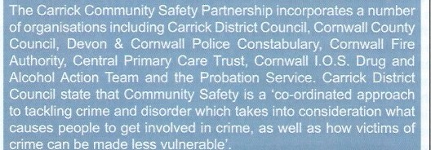Statistics....
'I had an occasion when I had to ring the police. I got an excellent, quick and helpful
response.'
Resident's Comment
Key Strategy:
•

77% of residents attending the prioritisation event stated vandalism as a key issue to be dealt with immediately.

How safe resident's feel outside after dark:

124 residents feel very safe. 143 residents feel fairly safe. 60 residents feel not very safe.
39 residents feel unsafe.

was a problem. Fore Street was also considered by respondents as the most difficult location for pedestrians to cross. The most popular suggested solution to this problem was for the installation of a designatedcrossing area near facilities.

Action Plan...

Traffic & Safety Policing Vandalism Youth Facilities

p.25 p.35 p.35 p.34

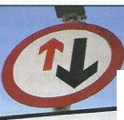There is no point in having speed cushions if cars park on or near them, they force cars to swerve out and the priority signs are being ignored' Resident's Comment.

Give way to oncom•ing vehicles

Key Points:

- Discussions should take place with Devon & Cornwall Constabulary Neighbourhood Beat Manager to develop a community crime action plan, as well as to establish a relationship with the community officers.
- As police provision is based on crime statitics, residents should be urged to report all crime.
- Community initiatives (e.g. Neighbourhood Watch) should be strengthened, with the aim of reducing petty crime.
- Identify funding requirements to implement security lights in specific locations identified.
- A Working Group should be formed to establish what activities/facilities are lacking for young people in the parish, seeking necessary funding for projects.
1 n

Litter was cited to be a problem in areas such as the Cobbles, around bus shelters, in the village hall carpark, in the church yard and in the playing field. The village is litterpicked / swept approximately every 6 weeks. However, if Carrick's Monitoring Officer visits the area and sees it needs extra cleaning or if the waste management team receive complaints, then they can carry out additional cleaning within 24/48 hours. Residents suggestions for dealing with litter included educating people to be more responsible for their waste, voluntary litter picks and employing a street cleaner. 79% of respondents think that there are not enough litter bins in the parish and many stated they also needed to be emptied more frequently. Suggestions for sites for new bins included areas by bus stops, in the car park, by the churchyard, outside facilities and in the main street Carrick District Council, however, argue that presently their are enough bins in the area and that they are emptied frequently enough. They do however state that if bins become full they will be able to empty them within 24 hours if notified. It should also be noted that some of the locations sited by residents for more bins do not fall into the Council's remit (ie. the churchyard and playingfield). There was also call for street waste bins to support recycling, this is also however unlikely as Carrick District Council are putting their resources into kerbside recycling.

Kerbside Recycling in Carrick has proved to be very successful and the District is now recycling 32% of its household waste, which is the highest rate in the County. In addition, the Waste Management Service has been advised that the service is a finalist in the national recycling awards. In Probus, the majority of residents use the scheme, with only 3 respondents stating they never use it 106 respondents stated they thought the service could be improved. One suggestion was to increase the range of plastics recycled. The Council state that there are, at present, no companies that take the other kinds of plastics for processing, but if an outlet was to be found they would extend what is collected. By 2008, steps will be taken to make recycling weekly, which will certainly help in being able to recycle more easily. Ensuring that litter is not left in the street after collection was another suggestion made by residents. Carrick state that if litter is left in the street due to the collectors not taking care in emptying the recyclate into the vehicles then residents should phone or e-mail the council and they will arrange for
the mess to be cleared up. A number of residents also require a lid for their bumber box. These at present are not provided free, but can be purchased from the Council.

Dog fouling was considered a very significant problem by 138 residents. and a fairly significant problem by a further 77. 69% of residents attending the prioritisation event stated dog fouling as a key issue to be dealt with immediately. Areas of particular concern include Fore Street, the path between the

'Toomuch rubbish is blown around before the recycling lorry arrives. Lids on boxes would help.'
Resident's Comment
20

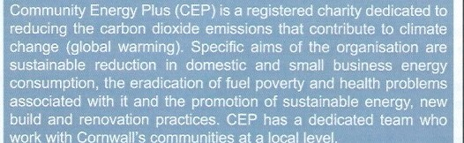Statistics....
'Please preserve our green area. So many properties are being squeezed into such a
small village' Resident's Comment
Key Partner: •
F.or more information visit www.cep.org.uk
69% of residents attending the prioritisation event stated dog fouling as a key issue to be dealt with immediately.

Action Plan...

Litter & Recycling p.36 Footpaths & Bridelways p.37 Dog Fouling p.38 Improving environment p.38 Development p.39
Vandalism p.35
Affordable housing p.24
Public Transport p.24

village hall and Gwel-an-Nans and Tregony Road. 223 residents stated that there were not enough poop scoop bins and that more needed to placed around the parish.

Youth Consultat ion revealed that the environment was the second most important issues for young people of age 4-11. Popular suggestions were the planting of more trees and cleaning up specific areas around the parish. The most popular location for this was below Treviglas Rise. With regards to educating children about recycling etc, there are plans for a Education Centre to be created down at Carrick District Council's 'Bulking Up Facility', where all the recycling materials go prior to going off for processing. As soon as this is completed schools will be invited to visit the BUF and see what happens to the materials, along with presentations so that they can learn about recycling and all other waste management issues.

Many comments were made by residents as to the need to protect both the built and the natural environment from unnecessarydevelopment. At the same time many residents recognised the need that future development would need to take place to ensure that adequate accommodation and facilities were available for future generations.

Key Points:
- Stopping the pollution of paths and roads by dog faeces needs to be a key priority.
•
•
- Historic buildings should be protected for the use and enjoyment of residents.
improving the village without losing its character and community spirit.
Any future development in the parish must be sympathetic to the environment, with the aim of
cleaner.
Further investigation should take place in regard to the Parish Council employing its own street
educational project)
school children in the planting and maintaining of green areas (environment/
Involve local
The Parish Council should seek to ensure that hedges and verges are maintained satisfactorily.
Locations should be identified where more trees, shrubs and flowers can be planted.
•
.
•

•

As Chairman of the Probus Parish Plan Committee I would like to acknowledge and thank the following members of the Committee and the Questionnaire Team especially:
Neil Staten for his unstinting support, help, advice and his computer skills.
Rob Adams, Headmaster of Probus Community School, for permitting the Working Group and the Questionnaire Teams the use of his school and for allowingthe pupils to make the 3D map of Probus.
Dennis Kearn for his work on the Questionnaire Team and his assistance in transporting the 3D visual display map-boards, many, many, times.
Sally Jones, of Carrick Regeneration Team, for all her help and guidance to me in carrying out the Plan and also to the members of her team in helping with the questionnaire.
Perran Tremewan, Marita Ward and Sharon Davey of CRCC.

I would also like to acknowledge the contributions of the following people in the village of Probus for their work on the Questionnaire Team:
Rob Cocking, Mandy Kendall (Parish Clerk), Daphne and Geoffrey Taylor, Phillip Chanter and John Arnold for chairing public meetings.
Sue Bryant and MelanieWarne for undertaking the Youth Questionnaire.
Thanks to the Hawkins Arms and the Probus Comrades Club for allowing public meetings on their premises.
The Village Hall Committee for the frequent use of the Village Hall. Probus News for keeping the village informed of progress.
Last but not least, Probus Parish Council and Chairman Councillor Dereck Colton.

Thank You!
Maud Hepworth

Taking the plan forward...
The overall goal of this plan 1s to help facilitate a future where quality of life in Probus is preserved and enhanced for everyone in the parish This entails enabling everyone in the community to have a voice in how their parish should develop and involving them in the development of the parish as much as possible. The publication of the parish plan should be seen as a starting point for the implementation of the action proposed within Monitoring, reviewing and updating the contents of the plan should be ongoing to ensure that the plan moves with the changing pansh and reflects the views of the pansh community

>>>
22

Affordable Housing p.24 Public Transport p.24 Traffic & Safety p.25 Accessibility p.25
Public Open Spaces p.26 Community Organisations p.26
Village Hall p.27 Outdoor Sports Facilities p.28 Indoor Sports Facilities p 29 Annual Carnivals/Parade p 29
Hobbies, Interests & Education p 30 Probus Primary School p.30
Learning Opportunities For Adults p.31
Youth Activities p.32 Park Facilities p.33 Skate Facilities p.33 Team Sports p.34 Youth Facilities p.34 Vandalism p.35
Policing & Neighbourhood Watch p.35
Local Businesses p.36 Litter and Recycling p.36 Dental Facilities p.37 Footpaths & Bridleways p.37
Dog Fouling p.38 Improving & Maintaining The Environment p.38 Building Conservation & Development p.39
action plan

Jccu | Aim ll A,-tinns |  | In ,..,..,...+jnnc | p;:i, II " II I Irr><>
Affordable l | Provide an | Monitor the need for low cost | St Merryn Meat | Carrick District Council: Housing Enabling  and Planning  Departments  Housing Corporation  Parish Council Working group  Local Landowners  Housing Providers: Housing Associations, Private Developers  ILocal Residents | Rated as a high priority by residents.  Plans for new housing  are already underway.  Work with District Council/  Housing providers  Iwill need to  be on going.
Housing | adequate  supply of | housing of all tenures via  the district and local needs | fields
 | affordable | housing surveys. | Garden Centre
 | homes for
 | a range of | Set up working party to | Land at the bottom
 | people within | investigatepotential sites and | of Treviglas Lane
 | the community | form working relationships with
 | (e.g. local | housing providers. | Brown field sites in
 | residentsin |  | the parish
' housing need, |  | Parish Council to work with
first time |  | District Council to ensure
buyers, young |  | number of new properties are
people, elderly |  | limited andin keeping with
people). |  | area.
 | Infill/brownfield | Infrastructure will need to
 | sites to be  utilised for | be considered if housing  developmentis to proceed e.g.
 | housing | sewage system, local facilities
 | development | (eg. school), parking etc.
 | wherever
 | possible.
Public Transport | An efficient, viable public and community transport system. | Working group to identify transport needs (using consultation data as initial basis) not currently met by existing public and community transport.  Work with CCC and West Cornwall Rural Transport Partnership Officer (WCRTP) and Parish Council to look  at realisLic improvements identified by residents, such as improving bus service information and investigating  community transport options. | Throughout the parish  Also work with neighbouring parishes. | Parish Council Working Group  Cornwall County Council  - Passenger  Transport Unit  West Cornwall Rural Transport Partnership Officer  Local Residents | Rated as a medium priority by residents.  Liasons can begin with WCRTPin  the near future.  Results may be achieved in the  medium to long term.
 |  |  |  | Age Concern
 |  | Work with WCRTP and CCC to research whether any existing bus services could be extended to meet some of the  parish's needs. If necessary |  | Young People  Cornwall Centre For Volunteers
 |  | lobby ccc·s Passenger Transport Unit for bus service improvements. |  | Bus Operators
 |  | Investigate transport needs for young people within the parish
 |  | e.g. accessing facilities.
 |  | Advertise bus timesin the parish magazine to help increase awareness of services.
 |  | Lobby bus operators for an integrated ticketing scheme.
24

r,;::;-;:;-;, | IAT. m |  | Locations IIPartners |  | Time
 |  | 1r a:c•.u''
Traffic & | -  Parish roads as safe as possible for all users.  Appropriate traffic speeds throughout parish. | Set up working group to | Fore Street | Parish Council | Rated as a
Safety |  | explore various traffic |  |  | key priority
 |  | management solutions, | Tregony Road | Working Group | by many
 |  | locations for pedestrian |  |  | residents.
 |  | crossings and law enforcement | St Austell Road | Cornwall
 |  | issues. |  | County Council | A working
 |  |  | School | -Highways & | group can
 |  | Liaise and work with Parish |  | Road Safety | be set up
 |  | Council, Cornwall County | Various other | Departments | in the near
 |  | Council Highways and Road | locations |  | future.
 |  | Safety Departments. as | throughout the | Devon&
 |  | well as Devon & Cornwall | parish | Cornwall | Results may
 |  | Constabulary on options and |  | Constabulary | be achieved
 |  | help available. |  |  | in the
 |  |  |  | Carrick District | medium to
 |  | Contact County Councillor, as |  | Council | long term.
 |  | ceuncillors also hold a budget
 |  | for small local improvements. |  | 1-ocal Residents
 |  | Using consultation data and further research if necessary |  | Local Businesses
 |  | to identify locations and times  where speeding traffic is a |  | Local School
 |  | major concern.
 |  | Consult residents and school to identify the type of crossings
 |  | reouired.
Accessibility | To ensure adequate parking whilst alleviating parking congestion on main roads.  Ease problem of dangerous, illegal and inconvenient parking.  To reduce heavy goods vehicles through residential areas. | Carry out further parish consultation on whether residents are in favour of car park provision to alleviate congestion on village roads.  If in favour. set up a working group lo work with partners to look at feasibility (including  funding) of securing additional land to ease the parking problems in the parish Disabled parking needs to  be considered in any project plans.  Once project outline is produced feedback to the community for approval.  In conjunction, liaise with Devon and Cornwall  Constabulary on how to taekle the issue of illegal parking e.g. double parking, blocking of drives, parking on comers and in cycle lanes etc. | The Square Fore Street  Near shops, post office and church  Carne View Road Chapel Street | Parish Council  Working Group  Cornwall County Council  -Highways  Devon & Cornwall Constabulary  Carrick District Council  Landowners Local Residents  Local Businesses | Medium term
 |  | Set up working group to monitor levels of road use and investigate alternative routes
 |  | for heavy goods vehicles.
 | I | Seek advice and help from annrowiate authorities

improved open spaces.

Investigate who is responsible for upkeep of public toilets.

Research funding opportunities for provisionof street furniture i.e.public benches, litter bins.

Publicise improvement plans in parish magazine andinform residents and businesses
of opportunities to sponsor seating etc...

Liaise with Church Counci,l looking at ways to improve the churchyar.d

Public benches Churchyard Busshelter/s

Cornwall Rural Community Council

Working Group

Cornwall County Council
- Environmental Department

Carrick District Council

Playing Field Committee

Advisory & Funding Bodies

Church Council

Friends of Probus Church

Community A variety of Promoting existing facilities Organisations community and organisations.
based
organisations Research funding opportunities for the benefit and feasibility for1he provision of residents. of a pennanent library,
Citizen's AdviceBureau and MP Surgery.Atpresent 1here is mobile library service.

Liaise with the Parish Council, District Councilandresidents to determine suitable locations (ie . existing community facilities}.

Identify volunteers tohelp arrange andbe involved in organisations.

Continued advertising of local events and organisations throughparish magazine.

Within theparish.

Possible locations include VIiiage Hall.

Parish Council Although
this issue Cornwall Rural is seen as Community important
CoullCll toresidents it is not
Working Group considered
to bea main
ComwaH priority for
County Council action.

Carrick District Medium CoullCll term.
Citizen's Advice

Advisory& Funding Bodies

Church CouncU

Friends of Probus Church

26

'?7

Conduct an audit of community
 | continuation of use and | facilities and consider the costs involved to repair, improve & | Football field | Cornwall Rural | is seen a key priority
 | improvements | equip the current hall. |  | Community | to residents.
 | to village hall  facilities. | Also, research into possibilities | Pavilion | Council | As such,  work should
 |  | of a new community centre. | Church | Working Group | begin in the
 |  |  |  |  | near future
 |  | Village Hall and Playing | School | Cornwall | to begin to
 |  | Field Committee to work |  | County Council | investigate
 |  | in partnership to develop |  | Early Years | oprions.
 |  | community facilities as requested byresidents through on going consultation, avoiding  duplication of work and |  | dept  Carrick District Council | Results may be achieved in the
 |  | competition. |  |  | medium to
 |  |  |  | Playing Field | long term.
 |  | Consider what other services  could be offered in existing/ |  | andVillage Hall  Committees
 |  | new facilities (using data
 |  | from event) to make it more |  | Local Clubs
 |  | sustainable.
 |  |  |  | School,
 |  | Seek funding & advice. |  | chool/
 |  |  |  | Playgoup
 |  | Enlist helpof possible partners
 |  | who might provide the services |  | Integrated
 |  | required. |  | Are.iPlan  - Objective 1
 |  |  |  | Advisory &
 |  |  |  | Funding Bodies
 |  |  |  | Church Council/
 |  |  |  | Friends of
 |  |  |  | Probus Church
 |  |  |  | Possible
 |  |  |  | partners:
 |  |  |  | Health Authority
 |  |  |  | &PCT,
 |  |  |  | Employment
 |  |  |  | Service, Adult
 |  |  |  | Education,
 |  |  |  | Surestart,
 |  |  |  | banks etc.
 |  |  |  | Other groups to
 |  |  |  | be identified

28
Ioutdoor  Sports | Residents to have access to | Set up working group to refer to report data and identify level | Within the parish | Working Group | A popular issue which
Facilities | outdoor sports | of sports requirements within |  | Cornwall | residents
 | facilities and | the parish for sports such as |  | County Council | general, feel
 | activities. | tennis, bowling, cricket etc. |  | Carrick District | should be a priority.
 |  | Investigate what existing |  | Council - Sports
 |  | facilities are available in or |  | Officer | Results
 |  | near the parish - e.g. Truro, St. |  |  | maybe
 |  | Austel.l |  | Parish Council | achieved in
 |  |  |  |  | the medium
 |  | Consider if it is more feasible |  | Playing Field | - long tenn.
 |  | and realistic to aocess existing |  | Committee
 |  | facilities - transport solutions
 |  | will be an important aspect of |  | School
 |  | this.
 |  |  |  | LandOwners
 |  | Promote existing facilities/
 |  | activities within the parish e.g. |  | Sports Alliance
 |  | Bowling Club.
 |  |  |  | Sport England
 |  | Consult parish residents to identify which sports activities they want and would use, e.g. tennis courts, bowling green, |  | Cornwall Community  Foundation
 |  | cricket pitch etc. |  | Local Network
 |  |  |  | Fund/Sports
 |  | Investigate possible funding, |  | Relief Grant
 |  | venues, and partners.
Local Clubs
(eg. Bowling,
 |  |  |  | Football)
 |  |  |  | Other Sports
 |  |  |  | Groups/Clubs
 |  |  |  | Localy

II SSIIP

II Aim

ll . I ll II I-
..
I A
II .-.. II. "1ers

lime

Indoor Sports
Residents to I; et up working group to refer
Within the parish Working Group
IApopular

Facilities
have access to 1 to report data and identify indoor sports ' level of sports requirements

Cornwall
issue, but was not

facilities and activities.
within the parish such as, a gym, indoor tennis, badminton, aerobics etc.

Investigate what existing facilities are available in or near the parish- e.g. Truro, St. Austell.

Consider if it is more feasible and realistic to access existing facilities - transport solutions will be an important aspect of this.

Consult parish residents to identify which sports activities they want and would use,
e.g. indoor-tenniscourts, badminton courts,,1erobics facilities etc.

Investigate possiQle funding, venues, and partners.
County Council

Carrick District Council • Sports Officer

Parish Council School
Sports Alliance

Sport England

Other sports groups/clubs locally

Cornwall Community Foundation
- Local Network Fund/Sports Relief Grant

Village Hall Committee
seen as such a priority as outdoor sports facilities.

Projects should be looked at in relation to any improve to existing hall etc.

Results maybe achieved in the medium
- long term.

Annual Carnival/ Parade

A carnival/ parade event that will include the whole of the community.

A working group set up to look into the feasibility of an Annual Carnival/Paradein the parish, funding, insurance costs, health & safety, entertainment lawsetc.

Involve the children, possibly through the school, with fund raising events,
i.e. competitions, sports tournaments, plays, sponsored run, bike rides etc.

Within the parish

Parish Council Young People Local Residents School
Working Group

Cornwall County Council
- Youth Service

Carrick District Council

Clubs/ Organisations

Local Community Buildings

Volunteers

Local Businesses

A popular suggestion. but not seen as an immediate priority.

Medium term.

'

,.,,..

Issue | Aim | II A |  | •• | -  "" | IILocations |  |  | Time
" LI rs
Working Group

Local Residents

Cornwall County Council - Adult Education, Arts and Libraries)

Carrick District Council

Parish Council School
Cornwall Community Foundation Local Network Fund

Parish Magazine

Parish Website

Village Hall Committee

Mobile Library Service
Hobbies Interests & | Residents to have access to |  | Form a working group to identify the recreational and educational needs of the parish. Investigate what  existing facilities are available in or near the pc;irish - e.g.  Truro, St. Austell.  Consider if it is more feasible and realistic to access existing facilities - transport solutions willbe an important aspect of this.  Consult parish residents to further identify what hobbies and educational activities they are interested in e.g. gardening club. computing, arts/crafts. cinema. concerts, ballroom dancing. languages etc.  Promote existing activities and groups e.g. through advertising in the parish magazine and/or on the parish website.  Investigate possible funding, venues. and partners. |  |  | ' Within the parish |  |  | IMedium  term  11
Education | a wide range of activities  1 throughoutthe
parish to suit the community.

Create an appropriate avenue to promote and advertise all recreational facilities offered within the parish.
Probus Primary School | To ensure that children have access to a range of facilities provided by  Probus Primary School both during and out of school hours |  | Work with School, parents and local authority to investigate the feasibility of providing access to the school library and computers out of school hours.  Discuss possibility of local residents/parentsvolunteering their time to staff the library out of school hours.  Liaise with PTA and school's Board of Governors on feasibility of obtaining funding for floodlit football/tennis court at Probus School. |  |  | Probus Primary School | Probus Primary School  Probus Primary School Parent Teachers Association (PTA)  Probus Primary School Board of Governors  Cornwall County Council  - Education, Arts & libraries dept, Early Years  Parish Council Local Residents  Local Children |  | Medium term

30

11
Leaming Opportunities For Adults | Provision of appropriate adult education facilities within the parish. | Iinvestigate the possibilities of providing local learning facilities- wor1ang with the partners identified.  Exploretraining/learningneeds andidentify aooess to these  if they cannot beprovided locally. | To be decided | Cornwall County Council  - Education, Arts & Libraries dept.,Adult education  Parish Council I  Working Group | Medium  term.
 |  | Utilise church halVschool or multi usehall facilities for local classes. |  | Garrick District Council
 |  | Wor1< with training providers. |  | Truro College
 |  |  |  | School
 |  | Further exploration required to identify barriers to teaming opportunities i.e. transport, childcare. |  | Family Leaming Local Residents
 |  |  |  | Surestart
Objective 1
-South East Cornwall Regeneration Project
 |  |  |  | West Cornwall Rural TransPQrt Partnership
 |  |  |  | Workers Educational Association (WEA)
Employment
Service

-Appropriate
32

Youth Activities | youthactivities andfacilities in the parish. | Check feasibifity of a wide range of youth activities/ sports in the parish i.e. tennis, archery, basketball, swimming pool, rugby dub, arts & crafts  dub, disco's etc. | King George Field School  Field behind  Parkengear Farm | IParish council  Young people  Working party | Akey priority to be started on in the near future.
 |  | Research costs & funding, venue, likely numbers of attendance, format (different agegroup sessions) etc. | Field near Poncio  Fields onleft of ForeS1reet | Cornwall County Council  - Youth Service  Carrick District Council
 |  | Obtain youth input and encourage involvement at the very earliest stageof any  project. | Fields below West EndBungalow  Parkengear Vean | Clubs/ organisations
 |  | Identify volunteers to help arrange <Ind be involved in activities. | Fields behind Femleigh | Local  Community Buildings
 |  | Seek advice from CCC | Fields near Nursery | Volunteers
 |  | Explore possibilities ofother youth projects - boatbuilding, car maintenance or other similar activities which young people may haveanInterest in. | ForeStreet | Local  businesses  Cornwall Rural Community Council: Social Inclusion Worker& Funding Advice
Community Foundation re: set up funcfing
- LocalNetwork Fund
Prinoe's Trust
 |  |  |  | Family Services

Issue
Park Facilities
Aim
A clean and tidy playing field offering a wide range of equipment
and facilities for children of all ages.

Actions L fjnns p u -rs limP.
( Research costs and funding King George Field IParish Council I Akey
on providing improved play priority to be
equipment. astro-turf, new TresowgarLane Young People started on nets for football field, 6 fields in the near
- 12 adventure playground, Working Group future. roundabout, see-saw, fireman's Behind Chai Front
pole,log climber, swing, Cornwall special needs play area. Fields behind West County Council improved facilities at playing End Bungalow - Youth Service fields e.g showers, changing
rooms, toilets etc. School Carrick District Council

Obtain youth input and encourage involvement at the very earliest stage of any project.
Fields on left of Fore Street

Clubs/ Organisations

Cornwall Rural Community Council: Social Inclusion
^{I} .Worker&
Funding Advice Local Residents
Foundation re: set up funding
- Local Network Fund

Prince' s Trust Family Services

Skate Facilities
Skateboard facilities to meet the needs of the parish.
Set up community based group with potential users, volunteers and Parish Council.

Lobby District Council in respect of need, and a district wide skateboard strategy (as in Penwith & Caradon districts).

Site identification/ feasibility/ funding to be researched as well as insurance cover and health & safety assessment.

Obtain youth & parental input.

Obtain information etc from suppliers.
Playing Field Village Hall In the Square
Community Group

Young People/ Potential Users and Parents

Parish Council

Carrick District Council Sports Officer

Local Businesses
- Sponsorship

Skate Equipment Suppliers

Community Police Officer

Family Services
While of interest to many young people and rated a
fair priority further consultation and research
is needed and results may only be achieved in the medium to long term.

Issue IIAim |  | Actions | Locations | Partners | Time
Team Sports | A variety of team sports available to all children in \he parish. | Liaise with parish children to identify the sports clubs and teams they would like in the communi\y e.g rugby team, basketball team. cricket team, tennis club, running club etc.  Liaise with Parish and District Council on possible sites, facilities, funding.  Involve the children at all stages.  Work with parents, residents and young people in the hope to encourage volunteers to help train teams and run clubs. | Throughout the parish | Icommunity  Group  IYoung People/ Potential Users  and Parents  Parish Council  Carrick District Council - Sports Officer  Local Business Sponsorship  Community Police Officer  Existing clubs School  Local Residents  Cornwall Rural Community Council: Social Inclusion Worker&  Fundina Advice | Medium term
Youth Facilities | A youth centre. with appropriate facilities.  A safe and secure outside lighted area for young people. | Children and young people to have a say and be involved in the setting up of new facilities within the parish, e.g. Internet Cafe, more shops, more litter bins. etc, their opinions to be taken into account.  Check feasibility of a youth centre in the parish - costs & funding, venue, likely numbers of attendance. format (different age group sessions) etc.  Identify possible location, liaise with children at all stages. perhaps encourage their help lo create their outside area.  Obtain youth input and encourage involvement at the very earliest stage of any project.  Identify volunteers to help arrange and be involved in a youth club.  Seek advice from CCC Youth Service on how to set up and run a youth club, in terms of  legislation/resoonsibilities etc. | Within the parish  Venue within parish to be identified.  I  I | Parish Council Young People Local Residents Working Party  Cornwall County Council  - Youth Service  Carrick District Council  Clubs/ Organisations  Local Halls Volunteers  Local Businesses  Cornwall Rural Community Council: Social Inclusion  Worker & Funding Advice | Another key issue to many  parishioners  Wort< to begin addressing young peoples needs can begin in the short term

34

...
....r .

 |  |  | ocations | Partners | mme
Vandalism | A well- maintained, clean and tidy parish that the community can take pride in. | Liaise with Devon & Cornwall Constabulary neighbourhood beat manager to develop a community crime action plan - and to establish a relationship with the community officers. | Church/ Churchyard  Bus shetters Park/playing field | Parish Council  Devon& Cornwall Constabulary  Local Residents | Rated the highest issue that needed to be dealt with  immediately
 |  | Explore community initiatives (e.g. NeighbourhoodWatch) with the aim or reducing petty crime.  Identify funding requirements | Village Hall | Cornwall County Council  Carrick District Council | li aisons with neighbour- hoodbeat  manager
 |  | to implement security lights in specific locations identified. |  | Local Businesses | should begin in the short term.
 |  | Working group to establish what activities/facliities are lacking for young people in the  parish. |  | Young People Cornwall
 |  | Seek necessary funding for youth provision in a bid to keep children occupied and off the streets. |  | Crime Prevention Officer
Policing | Asafe and secure community with an appropriate level of police presence. | liaise with residents, Crime Prevention Officer, Parish Council and District Council to improve existing NeighbourhoodWatch Schemes • set up more in other locations and provide  more information and publicity. | Throughout parish | Parish Council  Devon & Cornwall Constabulary  Local Residents | Another important issue to residents.  Medium term
 |  |  |  | Cornwall
 |  | Residents to communicate with Devon and Cornwall Constabulary on where they feel a police presence is  required. |  | County Council  Carrick District Council
 |  |  |  | Local Businesses
 |  |  |  | Young People Cornwall
 |  |  |  | Crime Prevention Officer
 |  |  |  | Local Neighbourhood Watch Co- ordinators

'

r-.-:, ..:.. . .... ,..,,, ;
 |  | ,z;;, .,,, .."'  ;: " I..;;- I· |  | ';) : | '";"', 2--........,.---::--
1  Local | Support for | Liaise with local businesses | Within the parish | Local | Training
Business | existing local | about training opportunities, |  | Businesses | needs were
 | business and | promoting existing business. |  |  | seen as
 | development | the possibility of a local |  | Parish Council | important to
 | of appropriate | chamber of commerce type |  |  | businesses
 | new | organisation specifically |  | Cornwall | and
 | businesses, | for businesses in Probus, |  | County Council | residents
 | creating job opportunities in | expanding business or moving  to new premises. |  | Adult Education  Services | but not a key priority
 | the parish for |  |  |  | for the
 | local people. | Consult with residents and |  | Local Residents | parish.
 | A wide range | local businesses on training  requirements within the parish. |  | Advisory | Medium
 | of training |  |  | Bodies: | term
 | available for | Parish Council and Cornwall |  | Federation
 | residents. | County Council Adult Education Department to |  | of Small Businesses/
 |  | work in partnership, looking at |  | VIRSA/Post
 |  | ways to best provide training |  | Office Ltd/
 |  | opportunities for local residents |  | Business Link/
 |  | e.g. computer, IT skills. |  | ROA/Objective
 |  |  |  | 1 Agricultural
 |  | Identify sites where existing |  | Dev. Team/
 |  | businesses can expand/move  to, or where new businesses can be develonAl'I. |  | CCC - Cornwall  Enterprise.
Litter & Waste | Adequate | Investigate feasibility of | The Cobbles | Parish Council | On-going
Recycling | local recycling
 | facilities  appropriately | (A) Improvement of existing facilities - in terms of | Bus Shelters | Carrick District Council
 | located and | extending range of items for | Church Yard
 | publicised, | recycling, regular maintenance |  | Cornwall
 | and therefore | (emptying) of currant facilities | Village Hall Car | County Council
 | well used by | and promotion of locations. | Park | - Environmental
 | residents. | (B) Extending and |  | Department
 |  | improving the kerbside | Playing Field
 | Adequate and | recycling service, increasing |  | Local Residents
 | strategically | the waste products which can | Shop Forecourts
 | placed litter | becollected. |  | Local
 | bins. |  |  | Businesses
 |  | Identifying locations in the
 | Improved | parish wherelitter is a problem |  | School
 | and extended | and providing litter bins.
 | kerbside  recycling | Liaise with school on educating
 | service. | children about recycling al'ld
 |  | keeping their environment litter
 |  | free.
 |  | Look into feasibility of
 |  | employing a village cleaner
 |  | and/or enlisting the help of
 |  | volunteers.

36

lss11A | IIAim | Actinns | II nr.::itinn s IIPartner |  | Time
Dental Facilities | All residents able to access NHS dentist | Contact Central Cornwall Primary Care Trust to investigate whether there are | Parish wide. as well as a district & county audit of | Parish Council  Health Authority | Long term  II
 | services. | options to improve the situation  locally e.g. piloting a mobile NHS dental surgery (part time), | facilities/services. | Dental Surgeries
 |  | utilising a local venue.
 |  | Investigate access to facilities elsewhere. |  | Central  Cornwall Primary Care Trust Patient
 |  | Contact the local MP for  support and help in drawing attention to the continuing problem of NHS dental service availability, |  | Liaison Service  (PALS)  Health Action Zone
 |  |  |  | Health Promotion
 |  |  |  | Service
 |  |  |  | Existing Health Services
 |  |  |  | Patient Forum
Footpaths & Bridelways | A network of accessible, well signposted and well-maintained | Public footpaths and bridleways to be identified and promoted to the community. | Throughout parish | Parish Council  Carrick District Council | Short term
 | footpaths and bridleways. | Obtain information on CCC Local Maintenance Partnership scheme and whether this would be of interest to Parish Council. Investigate this, and other ways in which paths could be maintained and  improved. |  | Cornwall County Council  - Environment Department  Wildlife Trust
 |  | Working Group to decide on possibility of creating new |  | Environment Agency
 |  | footpaths and bridleways. |  | Countryside Agency
 |  | Identify overgrown and neglected footpaths and seek necessary funding to restore to public use. |  | Working Group Local Residents
 |  | Seek to ensure adequate disabled access to footpaths and bridleways. |  | Local Landowners
 |  | Research possibility of producing leaflets/guides for local footpaths and bridleways. looking into obtaining funding if necessary.
17

 | To stop | Installation of suitable bins | Various footpaths
 | pollution of | for the disposal of dog waste | andlocations
 | paths and roads by dog  faeces and to | andneed to ensure regular arrangement for emptying of  bins. | throughout the parish. | Carrick District Council | as something that needs
 | stop bagged |  | Possible dog | Cornwall | immediate
 | faeces being | Promote public awareness of | walking area to be | County Council | attention.
 | left in hedges. | health risks to humans and | identified. | - Environment
 |  | livestock through contact with  dog mess. |  | Department | Short  - medium
 |  |  |  | Local Residents | term
 |  | Work with thelocalandDistrict
 |  | Councilon enforcing dog |  | Landowners
 |  | fouling regulations.
 |  | Research the possibility and
 |  | funding of a local dog warden.
 |  | Possible creation of dog
 |  | walking area.
Improving and | An attractive | Set up working party. | Various locations | Garrick District | On-going
maintaining  the | and green  environment | Identify location$ Where more | around the parish,  especially in the | Council
environment | with well  maintained | trees. shrubs and flowers can  be planted. | main part of the  village. | Parish Council
 | hedges and |  |  | EngHsh Nature
 | verges. | Seek to ensure that hedges | Local children
 |  | and verges are maintained satisfactorily. | suggested Parkengear Farm,  Parkengear | Cornwall Wildlife Trust
 |  | Involve local school children in the planting andmaintaining  of greenareas - environmenV educational project. | Vean, field near Poncio andbelow Treviglas Rise. | Environment Agency  ComwaD
 |  |  |  | County Council
 |  |  |  | - Countryside
 |  |  |  | Officer
 |  |  |  | Counlryside
 |  |  |  | Agency
 |  |  |  | School
 |  |  |  | Local residents

38

Development Historic | Information to be obtained on | Old Methodist | Parish Council On-,going
buildings | historical buildings/sites within | Chapel (Junk &
protected for | parish- i.e. listed buildings etc. | Disorderly) | Working group
the use and
enjoyment of | Cany out mapping exercise | Village Hall | Carrick District
residents. | and create database in order to |  | Council:
 | set up a protection scheme. | St. Merryn Meat | Housing
Improvements |  |  | Enabling
to run clown | Dilapidated buildings to be | Probus | and Planning
and derelict | identified and appropriate | Demonstration | departments
buildings in the | action taken. | Garden
parish, |  |  | English Nature
 | Funding to be investigated. | Throughout the
Sympathetic |  | parish | BTCV
development  -expand and improve the | Set up working group to  identify sites in need of redevelopment. |  | Cornwall Wildlife Trust
village without |  |  | National Trust
losing its | Liaise with local residents,
character and | Parish Counciland |  | English
community | District Council to decide |  | Heritage
spiril | onappropriate use of
 | redevelopment sites (e.g. |  | Funders and
 | affordable housing etc.) taking |  | advisory bodies
 | into consideration residents'
 | needs and the surrounding |  | Local
 | area. |  | Businesses
 | Working group and local residents to discuss plans future development. |  | Local residents and landowners Housing
 |  |  | providers:
 |  |  | Housing
 |  |  | Association,
 |  |  | private
 |  |  | developers

